**NAME:FAIZAN BASHEER**

**ROLL NO:24K0571**

**LAB TASK 4**

**1.Write a C program that takes a single character as input and check if the character is a vowel.**

**CODE**

**#include<stdio.h>**

**int main()**

**{**

**char ch;**

**printf("ENTER A CHARACTER:");**

**scanf("%c",&ch);**

**if(ch>=65 && ch<=90 || ch>=97 && ch<=122)**

**{**

**if(ch=='a' || ch=='e' || ch=='i' || ch=='o' ||ch=='u'|| ch=='A' || ch=='E' || ch=='I' || ch=='O' ||ch=='U')**

**printf("ITS A VOWEL");**

**else**

**printf("ITS CONSONAT");**

**}**

**else**

**printf("INVALID CHARACTER");**

**}**

**OUTPUT**

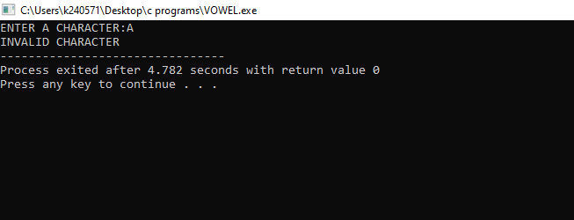

**2.Write a C program that describes the temperature as "Cold" (below 10°C), "Mild" (10-25°C), or "Hot" (above 25°C).**

**CODE:**

#include<stdio.h>

int main()

{

float temp;

printf("ENTER TEMPERATURE IN CELSIUS:");

scanf("%f",&temp);

if(temp<10)

printf("ITS COLD!");

else if(temp>=10 && temp<=25)

printf("ITS MILD!");

else if(temp>25)

printf("ITS HOT!");

else

printf("INVALID TEMP");

}

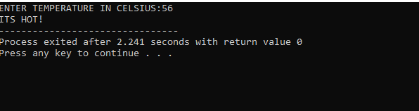

**3.Write a C program that checks if a student is eligible for a scholarship. The student must have a GPA of 3.5 or higher. If this condition is met, further check if the student has extracurricular activities, making them eligible**.

**CODE:**

**#include<stdio.h>**

**int main()**

**{**

**float gpa;**

**char ext_act;**

**printf("ENTER YOUR GPA(0.0-4.0):");**

**scanf("%f",&gpa);**

**if(gpa>=3.5)**

**{**

**printf("\nDOES THE STUDENT HAS EXTRA-CURRICULAR ACTIVITIES(Y OR N):");**

**scanf(" %c",&ext_act);**

**if(ext_act =='Y')**

**printf("YOUR ARE ELLIGIBLE FOR SCHOLARSHIP");**

**else**

**printf("YOUR ARE NOT ELLIGIBLE FOR SCHOLARSHIP");**

**}**

**else**

**printf("YOUR ARE NOT ELLIGIBLE FOR SCHOLARSHIP");**

**}**

**OUTPUT:**

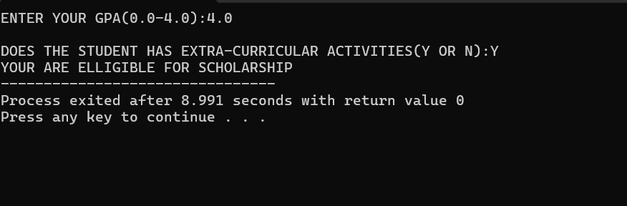

**4.Input two numbers and determine whether the numbers are equal or not, if numbers are not equal then determine which one is greater and which one is less.**

**CODE:**

**#include<stdio.h>**

**int main()**

**{**

**int n1,n2;**

**printf("ENTER TWO NUMBERS:\n");**

**scanf("%d%d",&n1,&n2);**

**if(n1==n2)**

**printf("GIVEN NUMBERS ARE EQUAL");**

**else**

**{**

**printf("GIVEN NUMBERS ARE NOT EQUAL\n");**

**if(n1>n2)**

**printf("FIRST NUMBER IS GREATER THEN FIRST");**

**else**

**printf("SECOND NUMBER IS GREATER THEN FIRST");**

**}**

**}**

**OUTPUT**

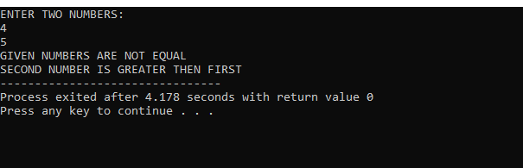

**5.Write a C program that takes two inputs: a character representing the vehicle type (C for Car, M for Motorcycle) and a number representing the specific model. Use a nested switch statement to display the model's details based on the vehicle type and model number.**

**CODE:**

**#include<stdio.h>**

**int main()**

**{**

**char v_type;**

**int n;**

**printf("ENTER YOUR VECHILE TYPE\nCAR(C) OR MOTORCYCLE(M):");**

**scanf("%c",&v_type);**

**printf("\nENTER YOUR VECHILE MODEL(1-3):");**

**scanf("%d",&n);**

**switch(v_type)**

**{**

**case 'C':**

**switch(n)**

**{**

**case 1:printf("SEDAN,1500CC,4-DOORS");**

**break;**

**case 2:printf("HATCHBACK,1300CC,5-DOOR");**

**break;**

**case 3:printf("SUV,2000CC,4-DOOR");**

**break;**

**default:**

**printf("INALID MODEL NO");**

**}**

**break;**

**case 'M':**

**switch(n)**

**{**

**case 1:printf("CRUISER,250CC");**

**break;**

**case 2:printf("SPORTS,600CC");**

**break;**

**case 3:printf("DIRT BIKE,450CC");**

**break;**

**default:**

**printf("INALID MODEL NO");**

**}**

**break;**

**default:**

**printf("INVALID VEHICLE TYPE");**

**}**

**}**

**OUTPUT**

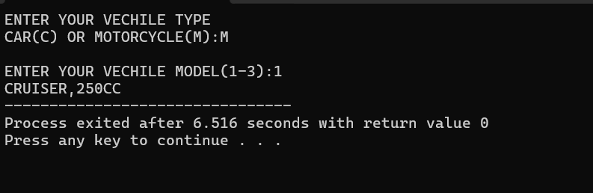

**6.The body mass index (BMI) is the ratio of the weight of a person (in kilograms) to the square of the**

**height (in meters). Write a program that takes two inputs, weight and height, computes the BMI, and**

**prints the corresponding BMI category:**

* **Starvation: less than 15**
* **Anorexic: less than 17.5**
* **Underweight: less than 18.5**
* **Ideal: greater than or equal to 18.5 but less than 25**
* **Overweight: greater than or equal to 25 but less than 30**
* **Obese: greater than or equal to 30 but less than 40**
* **Morbidly Obese: greater than or equal to 40**

**CODE:**

**#include<stdio.h>**

**int main()**

**{**

**float w,h,bmi;**

**printf("ENTER YOUR HEIGHT(INCHES) AND WEIGHT(LB):\n");**

**scanf("%f %f",&h,&w);**

**bmi = (w*703)/(h*h);**

**if(bmi<15)**

**printf("STARVATION");**

**else if (bmi<17.5)**

**printf("ANOREXIC");**

**else if (bmi<18.5)**

**printf("UNDERWEIGHT");**

**else if (bmi>=18.5 && bmi<25)**

**printf("IDEAL");**

**else if (bmi>=25 && bmi<30)**

**printf("OVERWEIGTH");**

**else if (bmi>=30 && bmi<40)**

**printf("OBESE");**

**else if (bmi>=40)**

**printf("MORBIDILY OBESE");**

**else**

**printf("INVALID BMI");**

**}**

**OUTPUT:**

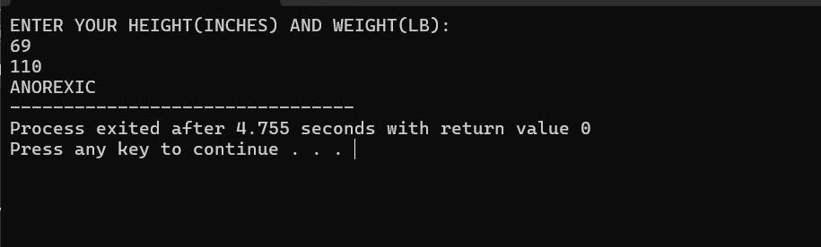

**7.Write a C program that calculates the shipping cost based on the shipping method chosen by the user. The user will input a letter representing the shipping method:**

* **E: Express (Rs. 200)**
* **S: Standard (Rs. 100)**
* **O: Overnight (Rs. 300)**
* **R: Regular (Rs. 50)**

**Use a switch statement to determine the cost and print it. If the input is not one of these letters,print "Invalid shipping method."**

**CODE:**

**#include<stdio.h>**

**int main()**

**{**

**char shipping;**

**printf("ENTER YOUR SHIPPING METHOD:\nE: Express S: Standard O:Overnight R: Regular\n");**

**scanf("%c",&shipping);**

**switch(shipping)**

**{**

**case 'E':printf("SHIPPING COST IS RS 200");**

**break;**

**case 'S':printf("SHIPPING COST IS RS 100");**

**break;**

**case 'O':printf("SHIPPING COST IS RS 300");**

**break;**

**case 'R':printf("SHIPPING COST IS RS 50");**

**break;**

**default:**

**printf("INVALID SHIPPING METHOD");**

**}**

**}**

**OUTPUT**

